CPE 166 Advance Logic Design
Harpreet Sidhu
Lab Section #3
Lab 4 Report
David Quintanilla

Table of Contents

- Introduction ……………………………………………………………………………3
- Part 1: SRAM Design ………………………………………………………………4-11
  - Ram Design ……………………………………………………………….. 4-6
  - Mem_FSM Design ………………………………………………………….. 6-9
  - Top Level Design …………………………………………………………… 9-11
- Part 2: Microprocessor Data Path Design ………………………………………….. 11-13
  - ALU Design ………………………………………………………………… 11-13
- Part 3: Microprocessor Control Path Design…………………………………………13-25
  - FSM ………………………………………………………………………….13-17
    - Data Path Design ……………………………………………………17- 19
    - MUX2_1 Design …………………………………………………… 19- 21
    - MUX4_1 Design …………………………………………………… 21-22
    - DFLIP_A Design ……………………………………………………22- 24
- Part 4: Final 4-bit Microprocessor Design …………………………………………..25-27
  - Final Top Level Design ……………………………………………………..25-27
- Conclusion …………………………………………………………………………. 28

Introduction
Lab 4 introduced the concept of designing a simplified microprocessor. Consisting of several components the microprocessor introduced topics such the SRAM Design and ALU and revisited topics such as FSM’s and top level designs for projects. In Part 1, I wrote a 4 bit number into the 32 address locations of the SRAM. After I finished writing the data I had to read the data from the RAM design. Following the table given in the lab instructions, Part 1 was fairly simple to complete. Part 2, dealt with creating the data path design for the microprocessor. This included creating two different types of MUX’s as well as creating D-Flipflops. The data path in part 2 was very complicated and required several hours of debugging. Using Table 4-1 in the lab instructions I created an ALU that implemented the data path circuit. Part 3 revisited FSM and ask to implement the control path for the microprocessor design.
Lastly, Part 4 was the final top-level design for the microprocessor. Using the formula M0 + (not M1) + Cin to check our results. This lab took longer than most labs, however with several hours of debugging this lab taught me how to properly design a microprocessor.

Part 1: SRAM Design

Ram Design (Verilog)
module ram ( address, data, cs, we, oe );
input cs, we, oe ;
input [3:0] address ;
inout [7:0] data ;
reg [7:0] data_out ;
reg [7:0] mem [0:1023]; //10-bit address bus, 8-bit data bus.

assign data = (cs && oe && !we) ? data_out : 8'bzzzzzzzz;

always @ (cs or we or data or address)

if ( cs && we )

mem[address] = data;

always @ (cs or we or data or address or data)

begin
if (cs && !we && oe)
data_out = mem[address];
end
endmodule

Ram Design(Test Bench)
module ram_tb();

reg cs, we, oe;

reg [3:0] address;
wire [7:0] data;

reg [7:0] data_out ;

ram uut (.cs(cs) , .we(we), .oe(oe) , .address(address) ,.data(data) );

assign data = (cs && oe && !we) ? 8'bzzzzzzzz : data_out;

initial
begin

#10 we = 1'b1; cs = 1'b1; oe = 1'b0; address = 4'b1010; data_out = 8'b1100011;
#10 we = 1'b1; cs = 1'b1; oe = 1'b0; address = 4'b1111; data_out = 8'b1000011;
#10 we = 1'b0; cs = 1'b1; oe = 1'b1; address = 4'b1010; data_out = 8'b1101011;
#10 we = 1'b0; cs = 1'b1; oe = 1'b1; address = 4'b1111; data_out = 8'b1100111;
#10 $stop;

end
initial $monitor($time, ". we = %d, oe = %d, we = %d, address = %d, data_out = %d", we,cs,oe,address,data_out);
endmodule

RAM Wave Form
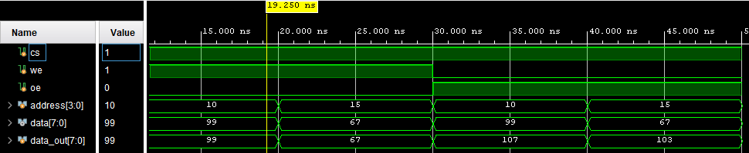
MEM_FSM (Verilog)
module mem_fsm ( clk, reset, address, data, cs, we, oe );
input clk, reset;
output [5:0] address;
inout [7:0] data;
output cs, we, oe;
reg cs, we, oe;
reg [5:0] address;
reg [7:0] data_reg;
reg [2:0] state;
parameter idle = 3'b000, s1= 3'b001, s2 = 3'b010, s3 = 3'b100;
assign data = data_reg;

always@(posedge clk or posedge reset)
begin
if (reset)
begin
state <= idle;
address <= 0;
end
else
case (state)
idle: begin
state <= s1;
address <= 0;
end
s1: begin
state <= s2;
address <= 0;
end
s2: begin
address <= address + 1;
if(address == 32)
state <= s3;
else
state <= s2;
end
s3:begin
if (address == 0)
state <= s1;
else
begin
address <= address -1;
state <=s3;
end
end

default: begin
state <= idle;
address <= 0;
end
endcase
end
always@(state)
begin
case (state)
idle: begin
cs = 0;
we = 0;
oe = 0;
data_reg = 8'bZZZZZZZZ;
end
s1: begin //writing
cs = 1;
we = 1;
oe = 0;
data_reg = 8'b11000011;
end
s2: begin //writing
cs = 1;
we = 1;
oe = 0;
data_reg = 8'b11000011;
end
s3: begin //reading
cs = 1;
we = 0;
oe = 1;
end
default: begin
cs = 0;
we = 0;
oe = 0;
data_reg = 8'bzzzzzzzz;
end
endcase
end
endmodule

Top (Verilog)
module top(clk, reset, address, data);

input clk, reset;
output [5:0] address;
output [3:0] data;

mem_fsm g1(.clk(clk),.address(address),.data(data),.cs(cs),.we(we),.oe(oe));
ram g2(.address(address),.data(data),.cs(cs),.we(we),.oe(oe));

endmodule

Top (Test Bench)
module top_tb();

reg clk, reset;
wire [5:0] address;
wire [3:0] data;

top uut(.clk(clk), .reset(reset), .address(address), .data(data));

always
begin

#5 clk = ~clk;
end
initial
begin

clk = 0;

#10 reset = 1;
#10 reset = 0;

#700 $stop;

end

endmodule

Top (Wave Form)

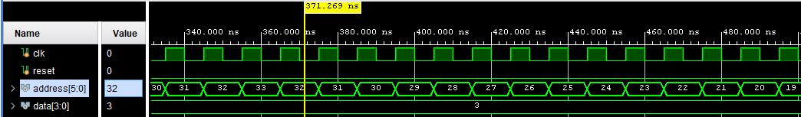

Part 2: Microprocessor Data Path Design
ALU Design (Verilog)
module ALU(A, B, S, cin, y);
input A, B, cin;
input [2:0] S;
output [3:0] y;

reg [3:0] y;
always@( S or A or B or cin )
begin
case (S)
0 : y = A + B + cin;
1 : y = A + ~B + cin;
2 : y = B;
3 : y = A;
4 : y = (A & B);
5 : y = (A | B);
6 : y = ~A;
7 : y = (A ^ B);
default : y = 0;

endcase
end
endmodule

ALU Design (Test Bench)

module ALU_tb;
reg[3:0] A, B;
reg[2:0] S;
reg cin;
wire[3:0] y;

ALU uut(A, B, S, cin, y);

initial begin

S = 0; A = 1; B = 2; cin = 1;

#10 S = 1; A = 1; B = 0; cin = 1;

#10 S = 2; A = 1; B = 0; cin = 1;

#10 S = 3; A = 1; B = 0; cin = 1;

#10 S = 4; A = 1; B = 0; cin = 1;

#10 S = 6; A = 1; B = 0; cin = 1;

#10 S = 7; A = 1; B = 0; cin = 1;
#10 $stop;
end
endmodule

ALU Design (Wave Form)

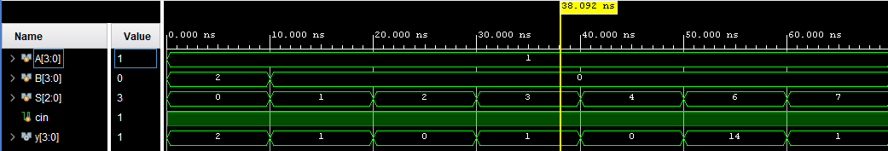

Part 3 Microprocessor Control Path Design

FSM (Verilog)
module FSM(clk, reset, clr, w, ce, sel, s);
input clk, reset;

output reg clr;
output reg [2:0] w, s;
output reg [1:0] sel;
output reg [3:0] ce;

reg [2:0] cs, ns;
parameter s0=0, s1=1, s2=2, s3=3, s4=4, s5=5;

always@(posedge clk or posedge reset) begin

if( reset ) begin
cs <= s0;
end else begin
cs <= ns;
end

end

always@(cs) begin

case(cs)
s0 : begin
clr = 1'b1;
w = 3'b100;
s = 3'b010;
sel = 2'b00;
ce = 4'b0000;
ns <= s1;
end

s1 : begin
clr = 1'b0;
w = 3'b100;
s = 3'b010;
sel = 2'b00;
ce = 4'b1111;
ns <= s2;
end

s2 : begin
clr = 1'b0;
w = 3'b100;
s = 3'b010;
sel = 2'b00;
ce = 4'b1111;
ns <= s3;
end

s3 : begin
clr = 1'b0;
w = 3'b100;
s = 3'b001;
sel = 2'b01;
ce = 4'b1111;
ns <= s4;
end

s4 : begin
clr = 1'b0;
w = 3'b100;
s = 3'b001;
sel = 2'b01;
ce = 4'b0111;
ns <= s5;
end

s5 : begin
clr = 1'b0;
w = 3'b100;
s = 3'b001;
sel = 2'b01;
ce = 4'b0111;
ns <= s5;
end

//default : ns = s0;
endcase
end
endmodule

FSM (Test Bench)

module FSM_tb();
reg clk, reset;
wire clr;
wire [1:0] sel;
wire [2:0] w, s;
wire [3:0] ce;

FSM uut(.clk(clk), .reset(reset), .clr(clr), .ce(ce), .w(w), .s(s), .sel(sel));
always
begin
#5 clk = ~clk;
end
initial
begin
clk = 0;
#2 reset = 1;
#10 reset = 0;
#150

$stop;
end
endmodule

FSM (Wave Form)

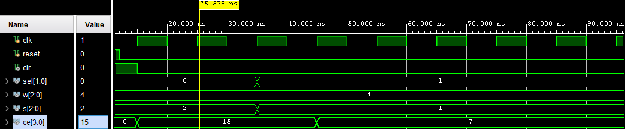

Data Path (Verilog)
module MUX_D_Combo(m0, m1, m2, cin, clr, w, ce, sel, s, clk, r0, r1, r2);
input clk, clr, cin;
input[3:0] m0,m1,m2,ce;
input[2:0] w, s;
input[1:0] sel;
output[3:0] r0, r1, r2;

wire [3:0] y0, y1, y2, y3, a, b;

MUX2_1 g1(.d0(m0),.d1(a), .s(w[0]), .y(y0));
MUX2_1 g2(.d0(m1),.d1(a), .s(w[1]), .y(y1));
MUX2_1 g3(.d0(m2),.d1(a), .s(w[2]), .y(y2));

DFLIP_A d1(.clk(clk), .clr(clr), .ce(ce[0]),.d(y0),.q(r0));
DFLIP_A d2(.clk(clk), .clr(clr), .ce(ce[1]),.d(y1),.q(r1));
DFLIP_A d3(.clk(clk), .clr(clr), .ce(ce[2]),.d(y2),.q(r2));
DFLIP_A d4(.clk(clk), .clr(clr), .ce(ce[3]),.d(y3),.q(a));

MUX4_1 g4(.d0(r0),.d1(r1),.d2(r2),.d3(4'b0000),.sel(sel),.y(b));

ALU a1(.a(a),.b(b),.s(s),.cin(cin),.y(y3));

Endmodule

Data Path (Test Bench)

`timescale 1ns / 1ps
module MUX_D_Combo_tb;
reg[3:0] m0, m1, m2, ce;
reg[2:0] w, s;
reg[1:0] sel;
reg clk, clr, cin;
wire [3:0] r0, r1, r2;

MUX_D_Combo uut(.m0(m0), .m1(m1), .m2(m2), .cin(cin), .clr(clr), .w(w), .ce(ce), .sel(sel), .s(s), .clk(clk), .r0(r0), .r1(r1), .r2(r2));

initial begin
clr = 1'b1; w = 3'b000; ce = 4'b0000; sel = 2'b00; s = 3'b000; clk = 1'b0; m2 = 4'b0000;
m0 = 4'b0101; m1 = 4'b0011;
cin = 1;
end
always #1 clk = ~clk;

initial begin
#10; clr = 1'b0;
#10; ce = 4'b0011; sel = 2'b00; s = 3'b010;
#10; ce = 4'b1011;
#10; ce = 4'b0011; sel = 2'b01; s = 3'b001;
#10; ce = 4'b1000;
#10; ce = 4'b0100; w = 3'b100;
#10; w = 3'b000; ce = 4'b0000; sel = 2'b00; s = 3'b000;
#10; $stop;
end
endmodule

Data Path (Wave Form)
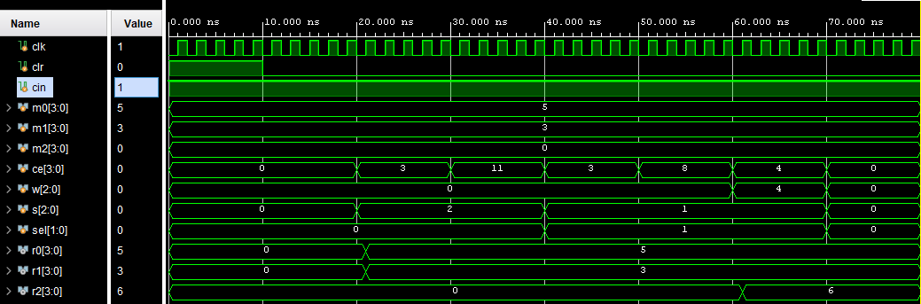

MUX2_1 (Verilog)
module MUX2_1(d0, d1, s, y);
input [3:0] d1, d0;
input s;
output reg [3:0] y;

always@( s or d1 or d0 )
begin
if (s)
y = d1;
else
y = d0;
end

endmodule

MUX2_1 (Test Bench)

module MUX2_1_tb();

reg[3:0] d0, d1;
reg s;
wire[3:0] y;
MUX2_1 u1(d0, d1, s, y);

initial begin
d1 = 0; d0 = 0; s = 0;
#10 d1 = 0; d0 = 0; s = 1;
#10 d1 = 0; d0 = 1; s = 0;
#10 d1 = 0; d0 = 1; s = 1;
#10 d1 = 1; d0 = 0; s = 0;
#10 d1 = 1; d0 = 0; s = 1;
#10 d1 = 1; d0 = 1; s = 0;
#10 d1 = 1; d0 = 1; s = 1;
#10 $stop;
end
endmodule

MUX2_1 (Wave Form)
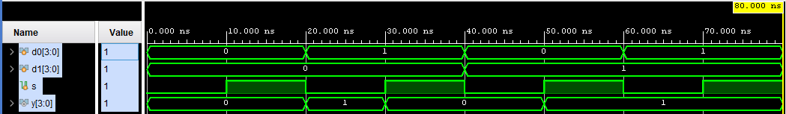

MUX4_1 (Verilog)

module MUX4_1(d0, d1, d2, d3, sel, y);

input [3:0] d3, d2, d1, d0;
input [1:0] sel;
output reg [3:0] y;

always@( sel or d3 or d2 or d1 or d0 )
begin
case (sel)
0 : y = d0;
1 : y = d1;
2 : y = d2;
3 : y = d3;

endcase
end
endmodule

MUX4_1 (Test Bench)
module MUX4_1_tb;
reg[3:0] d0, d1, d2, d3;
reg[1:0] sel;
wire[3:0] y;

MUX4_1 u1(.d0(d0), .d1(d1), .d2(d2), .d3(d3), .sel(sel), .y(y));
initial
begin
d0 = 0; d1 = 1; d2 = 2; d3 = 3; sel = 2'b00;
#10 d0 = 0; d1 = 1; d2 = 2; d3 = 3; sel = 2'b01;
#10 d0 = 0; d1 = 1; d2 = 2; d3 = 3; sel = 2'b10;
#10 d0 = 0; d1 = 1; d2 = 2; d3 = 3; sel = 2'b11;
#10 $stop;
end

endmodule

MUX4_1 (Wave Form)

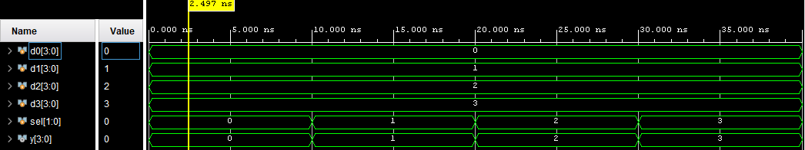

DFLIP_A (Verilog)
module DFLIP_A (clk, clr, d, ce, q);
input[3:0] d;
input clk, ce, clr;
output reg[3:0] q;

always@(posedge clr or posedge clk)

begin

if(clr) q <= 0;

else if(ce) q <= d;

end
endmodule

DFLIP_A (Test Bench)

module DFLIP_A_tb();

reg[3:0] d;
reg clk, clr, ce;
wire[3:0] q;

DFLIP_A utt(.clk(clk), .clr(clr), .d(d), .q(q), .ce(ce));

initial
clk = 0;
always
#10 clk = ~clk;
initial begin
clr = 1; d = 1; ce = 1;
#20 clr = 0;
#20 ce = 0;
#40
$stop;
end
endmodule

DFLIP_A (Wave Form)

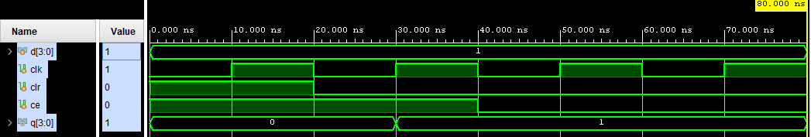

Part 4: Final 4-bit Microprocessor Design
Top Final (Verilog)
module Top_Final( clk, reset, m0, m1, m2, cin, r0, r1, r2);
input clk, cin, reset;
input [3:0] m0, m1, m2;
output [3:0] r0, r1, r2;
wire [2:0] w, s;
wire [1:0] sel;
wire [3:0] ce;
wire clr;
FSM fsm1(.clk(clk), .reset(reset), .clr(clr), .w(w), .ce(ce), .sel(sel), .s(s));
MUX_D_Combo mux_d_combo1(.clk(clk), .clr(clr), .w(w), .ce(ce), .sel(sel), .s(s), .m0(m0), .m1(m1), .m2(m2), .cin(cin), .r0(r0), .r1(r1), .r2(r2));
Endmodule

Top Final (Test Bench)
module Top_Final_tb();
reg clk, reset, cin;
reg [3:0] m0,m1,m2;
wire [3:0] r0,r1,r2;
Top_Final uut(.clk(clk), .reset(reset), .cin(cin), .m0(m0), .m1(m1), .m2(m2), .r0(r0), .r1(r1), .r2(r2));
always begin
#5 clk = ~clk;
end
initial begin
clk = 0; reset = 1; cin = 1; m0=0; m1=0; m2=0;
//#10 reset = 0;
// m0=4'b1000;
//m1=4'b0001;
//m2=4'b1111;
//cin = 1;
#10 m0 = 3; reset = 0;
m1 = 13;
//m2 = 2;
#150 $stop;
end
endmodule
Top Final (Wave Form)
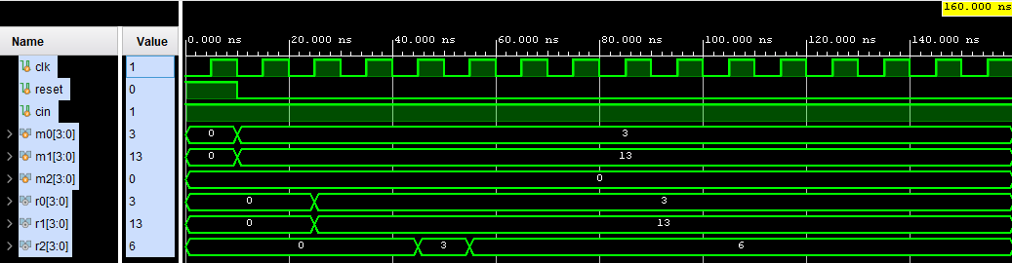

Conclusion

To conclude the main objective of this lab; which was to design a simple microprocessor that implemented the logic equation R2 = M0 +not (M1) + Cin was successfully created. The use of hierarchal design within the different modules was again used in order to link all modules together and create instances. It was again great practice for designing combinational and sequential circuits. I believe that this lab explored several topics that I was interested in on retouching and furthered my understanding of advance logic designs.

